**WESTON ON THE GREEN PARISH COUNCIL**

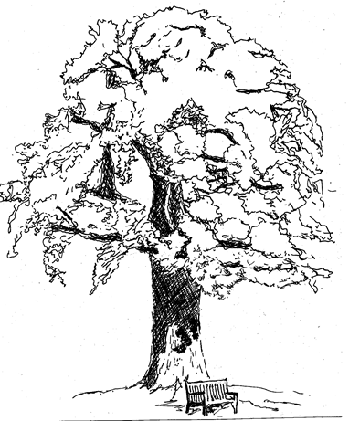

**TERMS OF REFERENCE:**

**TRAFFIC CALMING & TRANSPORT ADVISORY GROUP**

**Membership**

* One councillor from the Parish Council and a membership of up to seven people.
* Lead of the group to be reappointed at the annual Parish Council meeting.

**Quorum**

* A quorum will be three members including the Chair of the group.

**Meetings**

* The group shall meet as and when required.

**Delegated powers**

* None

**Role: In Scope**

* To liaise with the Parish Council on traffic and transport issues for the village, providing support and advice where necessary.
* To research and understand current and future traffic issues for the village.
* To collate, analyse and understand parishioner feedback on traffic and transport issues within the village.
* To liaise with external government organisations, bodies, local businesses or any organisations that could impact or improve on traffic and transport provision within the village.
* To inform parishioners of progress and updates to the groups agenda.
* To advise and provide guidance to the Parish Council on traffic calming options, community van operations and the provision of the public bus.
* To ensure appropriate traffic calming solutions that are approved by the Parish Council are implemented appropriately.
* To ensure the appropriate running of the community van for the benefit of parishioners, providing guidance on insurance, running costs, usage and other operational matters.
* To review the functioning of streets and the public realm with the aim of making village roads, streets and lanes safe, convenient and pleasant for all modes of transport including walking and cycling.

**Role: Out of Scope**

* To decide and implement traffic calming measures for the village within Parish Council approval.

**Stakeholders**

* Members of the village
* Oxfordshire County Council Highways, traffic and transport departments
* Campaign groups impacting on traffic and transport

**Reporting**

* To provide updates and reports to the Parish Council when necessary.

**Communications**

* To provide regular updates on progress to the Village News.
* To provide updates on the Parish Council website where necessary.