Resolution

To discuss and agree to spend up to £1,000 for noticeboards in the village.

Outline

We have a thriving village with many activities planned throughout the village, including an active Parish Council. Noticeboards to notify residents of Parish Council activities, and wider social activities going on in the village are limited. During the winter months many residents drive around the village, rather than walking, which means that notices on telegraph poles are of limited use.

It is proposed that we invest in the following:
4 planters with noticeboards attached, blackboard or poster style, to be agreed with the Clerk, associated soil and plants.

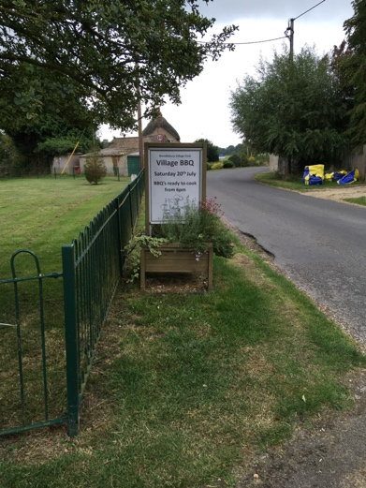

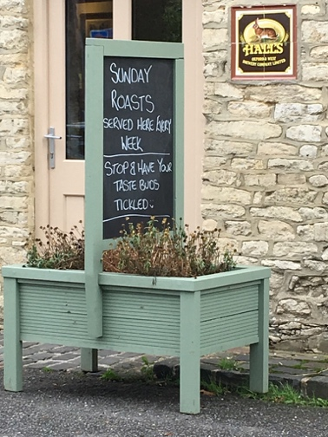

Locations are proposed as: Knowle Lane, Blacksmiths Close, Church Road (near the shop) and Church Lane (by the playing field).

Affordability
It is proposed that we use the Noticeboards budget line, total unspent budget year to date is £2,000.

