Works Department report.
The Works department reported in the Autumn on the clearance of the Oak Tree Pond. It was decided to delay the building of the Hibernaculum until the Spring Clean day of 6th April. Three children and miscellaneous adults helped in the construction of the Hibernaculum and a good time was had by all and a useful addition to the Oak Tree Pond created.
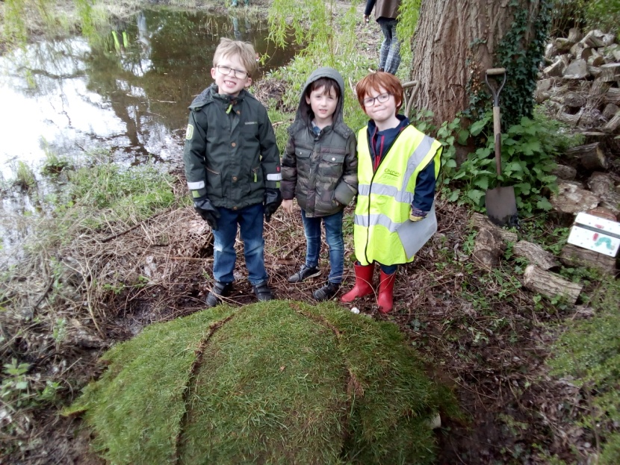
The Children’s allotment has been prepared as reported in the Playing Field report.
The path between the Village Hall and Westlands avenue has been “improved” by the Footpath’s Department following our request for some topping to the path, the whole thing was scraped and back-filled with Type 1 MOT. There were immediate complaints that this needed finishing with a topping. John Miller donated a load of ballast and a team spread this and rolled it with the loan of a hand roller from a villager (Len Ricketts)
