WESTON ON THE GREEN PARISH COUNCIL
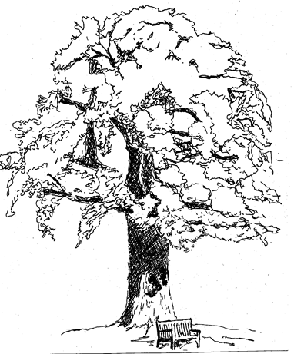
COUNCILLOR CASUAL VACANCY APPLICATION
Full Name:
Address:
 |  |  |  |  |  | Post Code:
Home Telephone: |  |  |  |  | Mobile:
Email:

Legal qualifications for being a Parish Councillor
To qualify you must be able to answer ‘Yes’ to both of the following questions:

Are you a British citizen, eligible Commonwealth citizen or a citizen of any member state of the European Union? | Yes / No
Are you 18 years of age or over? | Yes / No
To qualify you must be able to answer ‘Yes’ to at least one of the following questions:
- Are you registered as a local government elector for the Parish of Weston on the Green from the day of your nomination onwards. | Yes / No
- Have you lived in the Parish of Weston on the Green, or within 3 miles of its boundary during the whole of the 12 months before the day of your nomination and the day of election? | Yes / No
- Have you been the owner or tenant of land or other premises in the Parish of Weston on the Green during the whole of the 12 months before the day of your nomination and the day of election? | Yes / No
- Have you had your principal or only place of work in the Parish of Weston on the Green during the 12 months prior to the day of your nomination and the day of election? | Yes / No
Legal Disqualifications from being a Parish Councillor
You must also be able to answer ‘No’ to all of the following questions to be eligible to serve as a Councillor:
- Are you the subject of a bankruptcy restriction order or interim order? | Yes / No
- Do you already work for the parish council? | Yes / No
- Have you been disqualified under the Representation of the People Act 1983 (which covers corrupt or illegal electoral practices). | Yes / No
- Are you subject to the notification requirement of or under Part 2 of the Sexual Offences Act 2003, and the ordinary period allowed for making an appeal or application in respect of the order or notification has passed? | Yes / No
- Have you, within the last five years, been convicted of an offence in the UK, the Channel Islands or the Isle of Man, which resulted in a sentence of imprisonment (whether suspended or not) for a period three months or more without option of a fine? | Yes / No
Disqualification from being elected a member is set out in Section 80 of the Local Government Act 1972. Further information on standing as a Parish Councillor can be obtained from The Electoral Commission (guidance updated June 2022): https://www.electoralcommission.org.uk/i-am-a/candidate-or-agent/parish-council-elections-england

Please briefly outline why you are interested in being a Parish Councillor:
Please tell us something about the life experience you will bring to the Council, for example, previous local government experience, work in the voluntary or charitable sector, business experience:

Please tell us about the skills you feel you would bring to the Council, for example, professional qualifications, financial or project management expertise:
Are you prepared to undertake Parish Councillor training within Oxfordshire? |  |  |  | Yes / No
Please note that the majority of Council meetings are held in the evening and, unfortunately, under present legislation, the Parish Council is not permitted to contribute to the cost of Councillors’ childcare or care of dependents.
Weston on the Green Parish Council meetings generally take place on the first Wednesday of each month from 7.30pm in the Village Hall.
Declaration and Consent
I declare that I am eligible to become a Parish Councillor in the Parish of Weston on the Green and I certify that the contents of this application form are true and correct.

I consent to my details being retained if I am co-opted as a Councillor.

I consent to receiving Parish Council documentation via electronic means.

I consent to my name being published together with my contact number.
Signed |  | Date

Please return the completed form to:

Mrs Jane Mullane
Weston on the Green Parish Clerk
Oak View
North Lane
Weston on the Green
OX25 3RG
clerk@westononthegreen-pc.gov.uk
01869 350282

